1. Chalkboard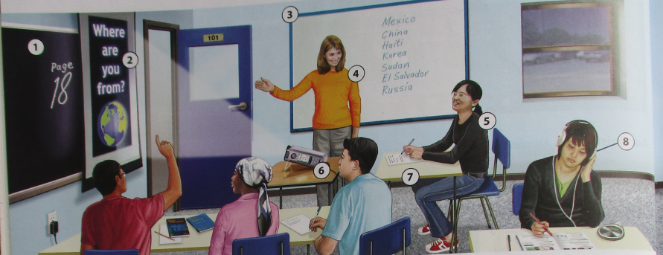  
     
   Tablo
2. Screen  
     
   Ekran
3. Whiteboard  
     
   Tablo blan
4. Teacher / Instructor  
     
   Pwofesè
5. Student  
     
   Elèv
6. LCD projector  
     
   Pwojectè LCD
7. Desk  
     
   Biwo
8. Headphones  
     
   Ekoutè
9. Clock  
   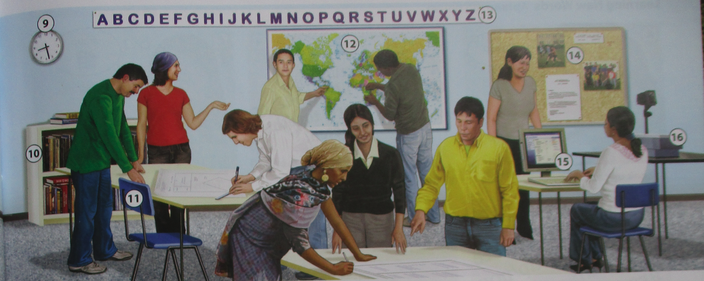  
   Òlòj
10. Bookcase  
      
    Etajè pou liv
11. Chair  
      
    Chèz
12. Map  
      
    Kat jewografi
13. Alphabet  
      
    Alfabè
14. Bulletin board  
      
    Tablo afichaj
15. Computer  
      
    Òdinatè
16. Overhead projector  
      
    Pwojektè
17. Dry erase marker  
    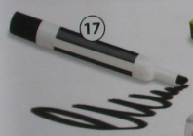  
    Makè ki efase ak chifon sèk
18. Chalk  
    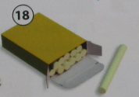  
    Lakre
19. Eraser  
    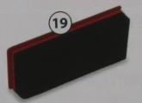  
    Efaswa
20. Pencil  
    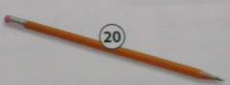  
    Kreyon
21. (pencil) eraser  
    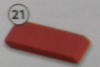  
    Gòm (kreyon)
22. Pen  
    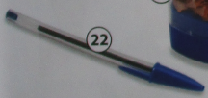  
    Plim
23. Pencil Sharpener  
    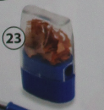  
    Tay Kreyon
24. Marker  
    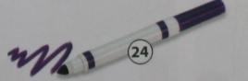  
    Makè
25. Textbook  
    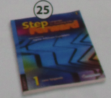  
    Liv
26. Workbook  
    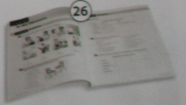  
    Liv egzèsis
27. 3-ring binder / notebook  
    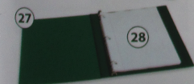  
    Klasè 3 zanno / Kaye nòt
28. Notebook paper  
      
    Papye pou Kaye nòt
29. Spiral Notebook  
    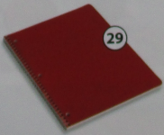  
    Kaye ki relye ak ti fè won
30. Dictionary  
    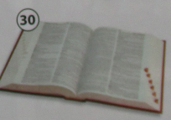  
    Diksyonè
31. Picture Dictionary  
    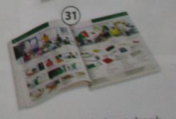  
    Diksyonè ki gen pòtre
32. Raise your hand  
    .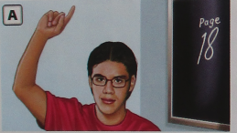  
    Leve men ou
33. Talk to the teacher.  
    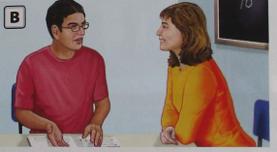  
    Pale ak pwofesè a.
34. Listen to a CD.  
    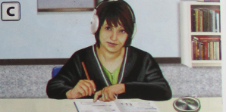  
    Koute yon disk konpak
35. Stand up.  
    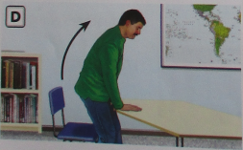  
    Kanpe.
36. Write on the board.  
    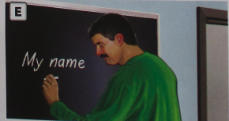  
    Ekri sou tabo a.
37. Sit down./ Take a seat.  
    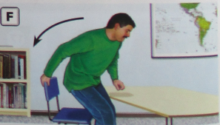  
    Chita / Pran yon chèz.
38. Open your book.  
    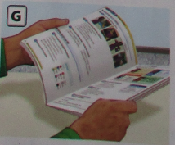  
    Ouvri liv ou.
39. Close your book.  
    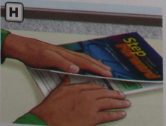  
    Fèmen liv ou.
40. Pick up the pencil.  
    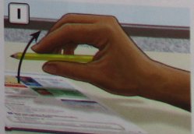  
    Ranmase kreyon an.
41. Put down the pencil.  
    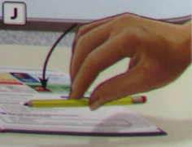  
    Depoze kreyon an.